EXPERIMENT 5
Document Question Answering using Retrieval-Augmented Generation (RAG)
Name | P Nishanth
Register Number | 192472292

AIM
To demonstrate a document question-answering system by retrieving relevant context and producing an answer based on that context.

PROCEDURE
- Prepare a small collection of sample documents.
- Define a question about the documents.
- Convert the documents and question into TF-IDF vectors.
- Calculate similarity scores and retrieve the most relevant document.
- Use the retrieved document as context for a sample answer.
- Display the question, retrieved context, and answer.

PROGRAM
from sklearn.feature_extraction.text import TfidfVectorizer from sklearn.metrics.pairwise import cosine_similarity

documents = [
"Python is a popular programming language.",
"Machine learning is a branch of AI that learns from data.",
"SQL is used to store and manage information in databases."
] question = "What is machine learning?"
vectorizer = TfidfVectorizer() doc_vectors = vectorizer.fit_transform(documents) question_vector = vectorizer.transform([question])

scores = cosine_similarity(question_vector, doc_vectors)[0] best_index = scores.argmax()
retrieved_context = documents[best_index]

# Sample answer based on retrieved context answer = (
"Machine learning is a branch of AI that learns from data." if best_index == 1 else "The retrieved document is: " + retrieved_context
) print("Question:", question) print("\nRetrieved Context:") print(retrieved_context) print("\nAnswer:") print(answer)

OUTPUT
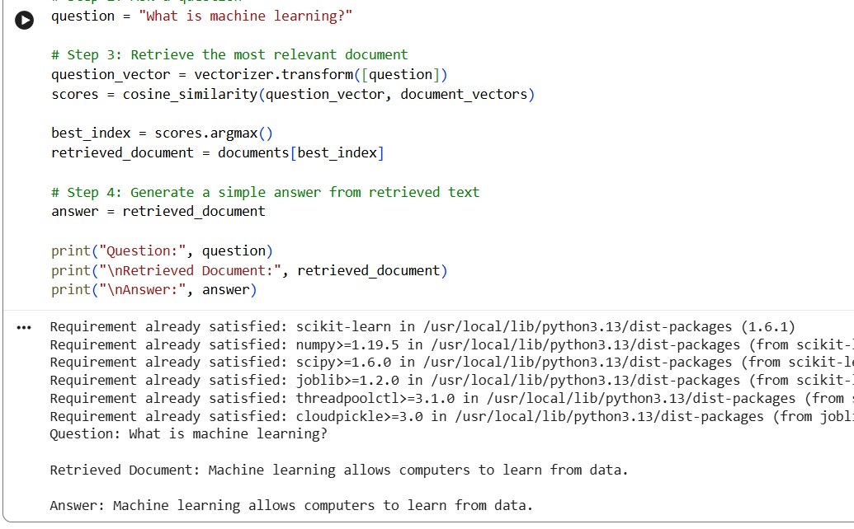

RESULT
Thus, a basic RAG workflow was demonstrated by retrieving relevant document context and producing an answer based on it.

